## **Assignment: Invoice Form with Login**

## Overview

You are tasked with developing a React application that replicates the provided design. The application must include a login system and a functional form, ensuring data persistence using local storage. The form functionality should be implemented using Formik, and the data must persist across page reloads.

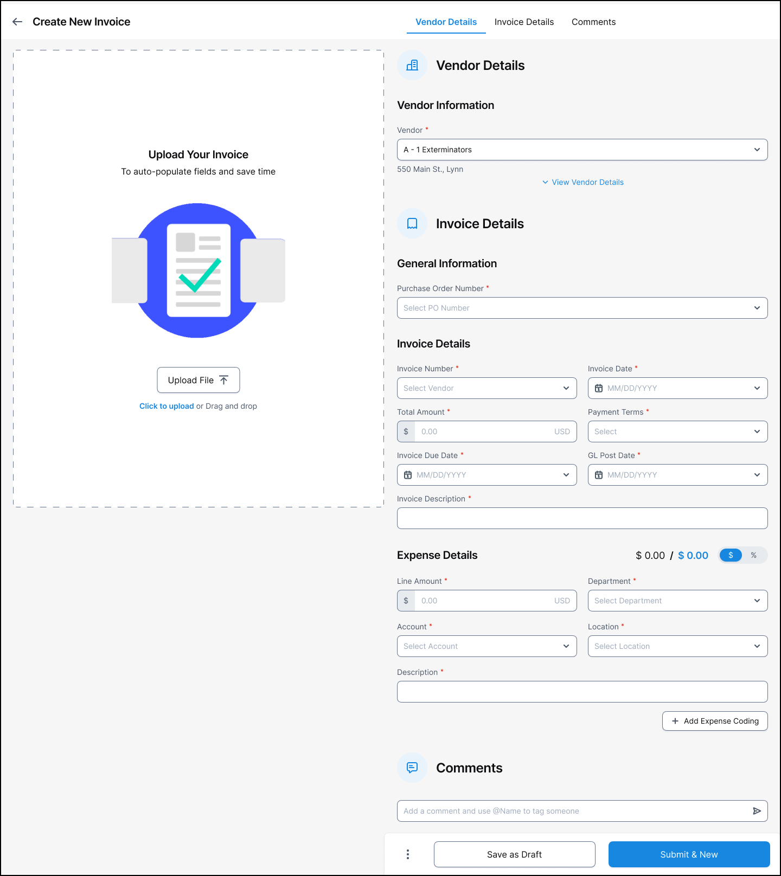

## Deliverables

* A fully functional React application replicating the design.
* Hosted live demo accessible via a publicly available link.
* A GitHub repository containing the project code, including a README file with setup and usage instructions.

## Requirements

## 1. Login System

* Login Form:
  + Create a login form where users can enter their username and password.
  + Validate the form inputs using Formik.
* Session Management:
  + Store the user’s session in localStorage upon successful login.
  + Redirect the user to the main application interface after login.
* Auto-Login:
  + Automatically redirect users to the main application interface if their session exists in local storage.
* Logout Functionality:
  + Include a logout button to clear the user’s session from local storage and redirect to the login page.

## 2. Replicate the Design

* Accurately replicate the provided design using React components and styling.
* Ensure responsiveness and alignment with the design specifications.

## 3. Functional Form Implementation

* Use Formik to build a functional form as per the design.
* Validate form inputs to ensure data integrity.

## 4. Data Persistence with LocalStorage

* Store form data in localStorage upon submission.
* Ensure that the form data persists across page reloads and is pre-populated when the page is revisited.

## 

## 

## 5. PDF Upload and Display

* PDF Upload Component:
  + Implement a feature that allows users to upload a PDF file from their local system.
  + Render and display the uploaded PDF within the application interface using a library like react-pdf.

## 6. Populate Form Fields with Dummy Data

* Button Functionality:
  + Add a button that, when clicked, populates all form fields and pdf view on the left side with predefined dummy data.

Bonus Features

* Form Validation: Implement comprehensive validation for all form fields.
* Error Handling: Display user-friendly error messages for invalid inputs.
* Dynamic Styling: Apply dynamic styles to indicate input validation status (e.g., error highlights).

## Technology Stack

* React for building the user interface.
* Formik for managing forms and validation.
* LocalStorage for data persistence.
* react-pdf for rendering PDFs.

## Submission Guidelines

### Code Repository:

Submit the project code in a GitHub repository.

Include a README file with clear instructions on how to run the application.

### Live Demo:

Host the application on a freely accessible platform and provide the link.

### Application Quality:

Ensure the application runs without errors and adheres to the provided design and functionality requirements.

## 

## Evaluation Criteria

* Adherence to the provided design.
* Code quality, structure, and use of modern React practices.
* Effective use of Formik for form handling and validation.
* Proper integration of local storage for data persistence.
* Implementation of optional bonus features (if any).
* Overall user experience and interface design.